Top Tips for Talking  (For Families)  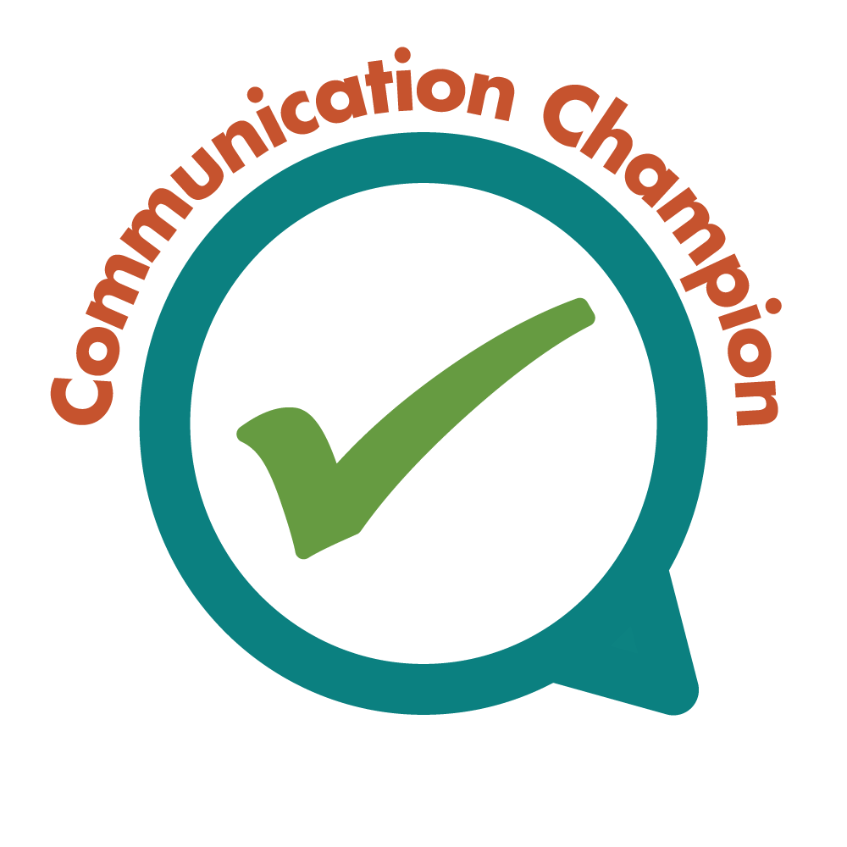  © Bath and North East Somerset Communication Champion Quality Mark | Top Tips for Talking!  Say your child’s name before you start talking to them  child’s name before you start talking to them  Draw your child’s attention to the fact that you are talking to them by using their name at the beginning of your communication. This is particularly important if they are in a group so they realise you are trying to communicate with them, | Top Tips for Talking!  Talk to your child about what they are doing  child’s name before you start talking to them  Come alongside your child when they are focused on something and comment about what they are doing “I can see you are moving the big bricks into a huge tower” or ”Baby’s clapping her hands .” Use words and sentences that the child will understand. | Top Tips for Talking!  Talk about the pictures in your child’s favourite book  child’s name before you start talking to them  are doing  Sharing or asking simple questions about pictures in a favourite book will add to the pleasure a favourite book gives and becomes a shared experience “Lovely rabbit isn’t he? So bouncy, bouncy, bouncy!” or “The clown has on those funny big baggy trousers”
Top Tips for Talking!  Turn off the TV and radio and enjoy talking and listening to your child  Reduce background noise from TV and radio so you give the message that “talking with you really matters, I am giving you my complete attention” Showing you valuing listening and talking times will encourages a child to join in with you. | Top Tips for Talking!  When you talk to your child get down to their level and look at them  It’s easier to talk to each other if you are face to face. Whether it be playing on the floor or the grass, kneeling at bath time or sitting together at meal times. Being down at your child’s level makes it easier to keep eye contact when talking together. | Top Tips for Talking!  Encourage your child to listen to and talk about the sounds around them  Spending time tuning into the sounds around us and talking about what you can hear helps children to develop good listening skills. A walk in the woods - “Can you hear the bird singing?” Watching building work -“Listen to the digger chugging over there!” “What can you hear outside today?” | Top Tips for Talking!  Show you value what your child says by repeating it back  Help your child use more words by adding to what they say. For example, if your child says “bus” you say “big bus”. If your child is using two words, then you could use three words. For example, child says, “Dolly breakfast”; adult says, “Yes, dolly is eating breakfast.”
Top Tips for Talking!  Have fun singing nursery rhymes and songs with actions over and over again  Children love to hear songs and rhymes especially from their favourite adults. They often say “again” and by hearing things repeated are making sense of sounds, rhythm and music. Sharing mistakes, being ridiculous, using different voices having fun makes for better relationships! | Top Tips for Talking!  Join in with your child’s play and follow their lead  child’s name before you start talking to them  A child’s language and thinking will develop through interactions with others. This arises naturally from a shared activity which provides something of interest to talk about and gives a clear context for words and meanings. | Top Tips for Talking!  Use simple, short sentences when talking with your child “would you like your car or teddy?”  child’s name before you start talking to them  Keeping sentences simple and short gives young children the opportunity to process words in sentences and come to an understanding of the meaning behind them. The number of words used and pace of communication all support this process. | Top Tips for Talking!  Take turns with your child when you’re doing an activity  child’s name before you start talking to them  are doing  A conversation is a 2 way process involving taking turns to listen, process sounds and respond, and listen process sounds and respond again. It is a learnt process and young children need to experience this for themselves in order to know how to communicate well
Top Tips for Talking!  Talk about something you and your child can both see  Spending time sharing experiences can be a valuable time for learning more about communicating. In the buggy, on a bus, on the school run, shopping and outside play are all times to point out and talk about what you both can see. “I can hear the ambulance” and “This is the shoe shop, look at those red boots” | Top Tips for Talking!  Repeat back your child’s language in the correct way if it’s not quite right  Praise the child’s efforts, even if the results aren’t perfect. If a child makes an error in a word or sentence, simply say the correct version rather than pointing out the mistake. For example, if the child says, “I goed to the park”, you might say “Wow, so you went to the park”. | Top Tips for Talking!  Give your child choices throughout the day  “would you like your car or your teddy?”  Children need opportunities to express their preferences and begin to think about decision making. Asking questions giving and them opportunities to select supports this. ”Would you like to have milk or water to drink?” “Do you want to wear these jeans or those leggings today?” | Suggestions of how to use the top tips:  - Try out some of the tips in your everyday life and share with other family members  - Talk together about what you notice happening  - Focusing on one Top Tip or just some at a time so you can get to know each one well and feel confident to have a go at the rest

